System communication Interface

Specifications

Summited to :sir amir Iqbal

BY:shabaz Khalid

14006105013

**Specifications..**

The system shall be a standalone and for communication with other components we using local host (my sql)

our communication will be based on database (name: hotel) as show in

figure:

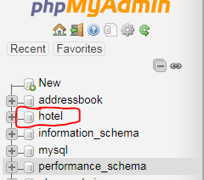

**Schema….**

There will be the tables which is use to communicate between use cases

For login user data or new entity table will be shown in figure:

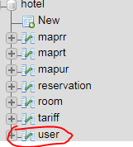

**Reservation …**

Reserving the new room and the data which is related to reservation will be the part of reservation table as shown

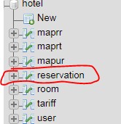

Note :

These tables Which is relative to the database “hotel” provides the communication between my use case if me emerged more use cases then we just create other table but use the same database..